***Pet bottle***

***Polyethylene Terephthalate (PET): PET is a thermoplastic polymer that belongs to the polyester family. It is made from the polymerization of terephthalic acid and ethylene glycol.Headaches.***

* ***Small PET Bottles (100ml to 500ml)***
* ***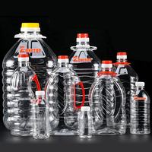*Price Range: PKR 8 to PKR 20 per bottle (individual pricing)**

**For bulk purchases (e.g., 1000 or more units),**

**The price can Drop to around PKR 5 to PKR 12**

**Per bottle Depending on the supplier.**

* ***Medium-Sized PET Bottles (500ml to 1L)***
* Price **Range**: PKR 15 to PKR 30 per bottle (individual pricing)

Bulk pricing can range from **PKR 10 to PKR 20 per bottle** for larger orders.

* ***Large PET Bottles (1L to 5L)***
* Price **Range**: PKR 40 to PKR 100 per bottle (individual pricing)

• Bulk pricing can be around **PKR 25 to PKR 70 per bottle** for large quantities.